Assistant Principal message:

BODY SAFETY AT MELTON WEST PRIMARY SCHOOL
Last week a number of parents attended the Body Safety information sessions conducted at the school on Wednesday July 13th, 2016. There was a morning session at 9:30am and an evening session at 6:00pm.
The presenters conducted very informative sessions that really assisted, parents/carers and guardians to learn about their role in protecting and educating their children, as well as having the opportunity to find out all about the sessions in which their children will be taking part.
Parents, guardians and carers who attended the sessions were given information about the program and how they can continue to support their child at home by helping children identify body warning signs, talking with trusted adults and what to do if a child discloses abuse.
Deanne, the presenter also provided information about strategies to teach your child protective behaviours when they are online and what parents, guardians and carers need to be aware of when their child is using the internet or social media.
The Body safety and protective behaviours education being conducted at the school over the next few weeks is a way of keeping children safe. It’s about educating children with the necessary skills and information to be empowered, and educating the adults in their lives to help prevent abuse by becoming aware of the situations where it may take place.
The Body Safety program at Melton West has been funded by a number of organisations who like to collect information about the success of the program. We have sent a letter home asking for your permission to collect this information. Please sign and return the note to school.

Kind regards
Jennifer O’Connor
Assistant Principal Prep-2 Learning Community

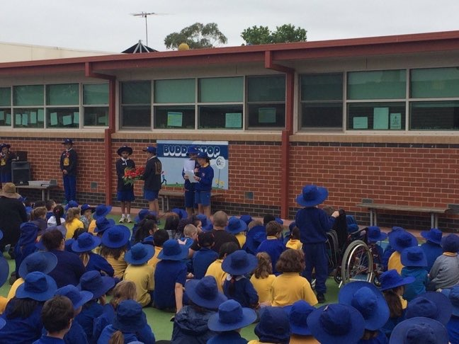
Message from our School Vice Captains

Hello everyone,
Last week was the first week back at school, all of the students have settled in well.
All the Grade 5’s & 6’s have a rugby clinic which will be going for 5 weeks; at the end they will play a game of Rugby.
In Term 3 the school will be taking part in the Body Safety program.

Vice Captains
Brooklyn Pritchard & Shehrish Khurshid

MWPS
Partners in learning

Getting it right in reading!

The importance of a ‘Book Walk’
A book walk – no I’m not talking about taking your dog and favourite picture book for a walk down the street or to the neighbourhood park. A book walk is a literary practice that is a great way for students to become excited and familiar with the book they are about to read as well as activate any prior knowledge they might have on the topic and pre-emptively discuss any difficult vocabulary.
Prior to reading a book with your child, have them first look at the front cover; read the title, the author and illustrator’s names and look at the picture. Ask your child to predict what they think the book might be about by looking at the front cover. Use the 5W’s (Who, What, Where When and Why) and How as a guide for asking questions. Then flip the book over and look at the blurb on the back cover. This often gives a little more insight about what the book is about. Then begin to flip through the book, page by page, looking at the pictures and words but not actually reading the page. Continue to ask your child questions about what they think will happen in the book and what they think the pictures are telling them (inferring or reading between the lines). While flipping through the book, this is a good time to stop and read together any difficult words. This will help them later on while they are reading to maintain fluency and understanding. During a book walk it is important that you don’t give too much away about your feelings or understanding of the book. This way your child becomes more engaged as they can discover as they read whether their predictions were accurate or whether the book took a turn that they didn’t expect.
Now that the book walk is complete, it is time to read the book together. Continue to ask questions and refer back to what your child said during the book walk and watch how your child’s literary experience is magnified by the discussion and conversation you can have around a single book.

Marvelous Math’s

MULTIPLYING STUDENTS ABILITY TO THINK SMARTER NOT HARDER

Through hours of practice young children expend enormous amounts of time and neural energy laboring over memorising the multiplication tables, encountering high rates of error and frustrations. They are able to remember the names of their friends, addresses, phone numbers and movie titles without any trouble. Obviously there is nothing wrong with their memories, except when it comes to multiplication tables. Why are they so difficult from children to remember?

One answer is when learning multiplication tables we start with the 1 times table and work our way up to 10 times table. This step-by-step process results in 100 (10x10) separate facts to be memorised. Children have little difficulty remembering the 1 and 10 times tables because they are consistent with their base-10 finger manipulation strategy. Now that leaves 64 separate facts (each of 2, 3, 4, 5, 6, 7, 8, 9, multiplied by each of 2, 3, 4, 5, 6, 7, 8, 9). Why do children need to learn 64 separate facts? By simply showing them commutativity in multiplication (3x8 is the same as 8x3), we can cut the total numbers of 64 separate facts nearly in half, to just 36 (the number of the four pairs of identical numbers, eg. 2x2 or 5x5 cannot be reduced). This is a more manageable number, but it still does not solve the problem.
Children often practice memorising their multiplication tables at home. Introducing them to activities using dots or pictures on cards can help them practice successive addition (the underlying concept of multiplication). Students have an innate sense of patterning and this will assist them when recalling multiplication tables, in preference to attempting to memorise the tables themselves.
Each child learns differently and that needs to be factored into their learning process. Teaching them to think smarter and not harder in the way that they learn their multiplication tables will positively contribute to their success in learning and recalling the multiplication tables.

