Melton West Primary School: Grade 3-6 Digital Backpack 2021

As well as different physical tools that your child needs for their learning at school, there are also digital tools that help them in their learning. Many of these are accessed online and require your permission for us to establish accounts for your child.
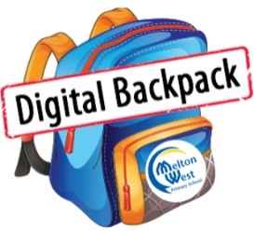
To allow us to set up these essential tools for your child, please sign each of the boxes below. While every class may not use all tools, signing and returning this form will allow the teacher to select those most appropriate to the task at the time. If you need any further information about the tools listed, please visit our website or speak to your child’s teacher.
Child’s Name: _____________________________________________
Child’s Class: _____________________________________________
Parent’s/Guardian’s Name: _____________________________________________
\
Grades 3-6—1-1 iPad Pilot Program Agreement for 2021

Melton West Primary School has been exploring ways that we can use digital technologies as part of the teaching and learning process.

In 2021, all students in Grades 3-6 have been provided with the opportunity to trial a 1-1
iPad Pilot Program. This program will allow teachers to investigate where mobile technologies fit into our teaching and learning environment and gather information that will allow the school to make informed decisions regarding the future of its digital technologies.

Each child in Grades 3-6 will be provided with a school-purchased iPad at no cost to families. As each iPad has been paid for by the school, the iPad will remain on schoolgrounds and cannot be taken home. Normal classroom teaching and learning will occur across the trial period with these iPads used to support and enhance learning.

This pilot is due to start in Term 1, 2021 and conclude at the end of Term 4, 2021.

If you have any queries about the 1-1 iPad Pilot Program, please feel free to contact Mr Jayden Spudvilas-Powell, the Grade 5/6 Team Leader and Digital Pedagogies School Leader.

I give consent for my child, listed above, to participate in the 1-1 iPad Pilot Program and receive their own iPad for purposeful learning tasks at school for the duration of the pilot.

Parent/Guardian Signature: __________________________________ Date: ___________________________

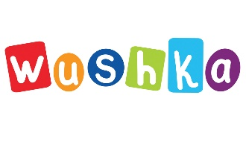
Wushka is a cloud-based digital reading program, which offers over 1000 levelled books to
support students learning to read. Wushka can be accessed on any device, making it perfect for school and home reading. The program also provides teachers with real-time data, so intervention can be provided where needed.

The information required to set up a Wushka account for students is their full name, year level and class name. Students will also be supplied with a username and password.

I give consent for my child, listed above, to use Wushka for purposeful learning tasks at school and home.

Parent/Guardian Signature: __________________________________ Date: ___________________________

Melton West Primary School: Grade 3-6 Digital Backpack 2021

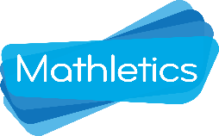
Mathletics is an online e-learning platform that gives our school access to a worldwide Maths community of over 3 million students. Teachers assign Maths tasks for each student based on the learning taking place in class or individual learning goals. Mathletics also offers ‘Live Mathletics’ where students challenge other students around the world to develop rapid recall of number facts.

The information required to set up a Mathletics account for students is their full name, year level and class name. Students will also be supplied with a username and password.

I give consent for my child, listed above, to use Mathletics for purposeful learning activities at school.

Parent/Guardian Signature: __________________________________ Date: ___________________________

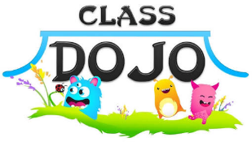
ClassDojo is a communication app for the classroom. It connects teachers, parents and students who use it to share photos of learning and messages during the school day. ClassDojo also allows teachers to track students’ negative behaviours easily and efficiently. Students are awarded ‘bubble points’ when they display behaviours that are consistent with the school’s values, which parents can view once they are connected to their child’s class.

The information required to enroll students in ClassDojo is their full name, year level and class name. Parents and guardians will be provided with an invitation to connect to their child’s class on ClassDojo. Students will also have the option to connect to ClassDojo with further permission from their parent or guardian.

I give consent for my child to be enrolled on ClassDojo and have their work samples published.

Parent/Guardian Signature: __________________________________ Date: ___________________________

Google’s G Suite for Education includes Gmail, Drive, Classroom, Calendar and a variety of other digital resources designed for educational purposes. Students can collaborate with others and access their work from any Internet-enabled device at home or school. G Suite for Education provides users with closed access to these resources, ensuring that students can only communicate and share documents with teachers and other students within the school.

The information required to set up a G Suite for Education account for students is their full name, year level and class name. Students will also be supplied with a username and password.

I give consent for my child to use G Suite for Education for purposeful learning activities at school.

Parent/Guardian Signature: __________________________________ Date: ___________________________

