Melton West Primary School: Prep – Grade 2 Digital Backpack 2021

As well as different physical tools that your child needs for their learning at school, there are also digital tools that help them in their learning. Many of these are accessed online and require your permission for us to establish accounts for your child.
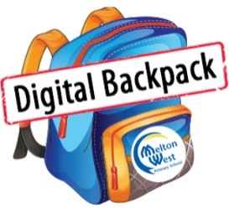
To allow us to set up these essential tools for your child, please sign each of the boxes below. While every class may not use all tools, signing and returning this form will allow the teacher to select those most appropriate to the task at the time. If you need any further information about the tools listed, please visit our website, or speak to your child’s teacher.
Child’s Name: _____________________________________________
Child’s Class: _____________________________________________
Parent’s/Guardian’s Name: _____________________________________________

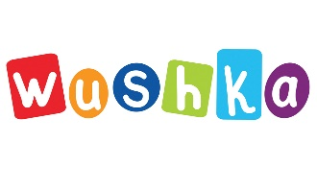
Wushka is a cloud-based digital reading program, which offers over 1000 levelled books to
support students learning to read. Wushka can be accessed on any device, making it perfect for school and home reading. The program also provides teachers with real-time data, so intervention can be provided where needed.

The information required to set up a Wushka account for students is their full name, year level and class name. Students will also be supplied with a username and password.

I give consent for my child, listed above, to use Wushka for purposeful learning tasks at school and home.

Parent/Guardian Signature: __________________________________ Date: ___________________________

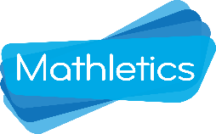
Mathletics is an online e-learning platform that gives our school access to a worldwide Maths community of over 3 million students. Teachers assign Maths tasks for each student based on the learning taking place in class or individual learning goals. Mathletics also offers ‘Live Mathletics’ where students challenge other students around the world to develop rapid recall of number facts.

The information required to set up a Mathletics account for students is their full name, year level and class name. Students will also be supplied with a username and password.

I give consent for my child, listed above, to use Mathletics for purposeful learning tasks at school.

Parent/Guardian Signature: __________________________________ Date: ___________________________

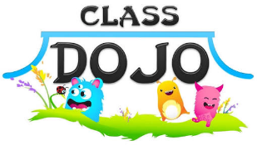
ClassDojo is a communication app for the classroom. It connects teachers, parents and students who use it to share photos of learning and messages during the school day. ClassDojo also allows teachers to track students’ negative behaviours easily and efficiently. Students are awarded ‘bubble points’ when they display behaviours that are consistent with the school’s values, which parents can view once they are connected to their child’s class.

The information required to enroll students in ClassDojo is their full name, year level and class name. Parents and guardians will be provided with an invitation to connect to their child’s class on ClassDojo. Students will also have the option to connect to ClassDojo with further permission from their parent or guardian.

I give consent for my child to be enrolled on ClassDojo and have their work samples published.

Parent/Guardian Signature: __________________________________ Date: ___________________________

